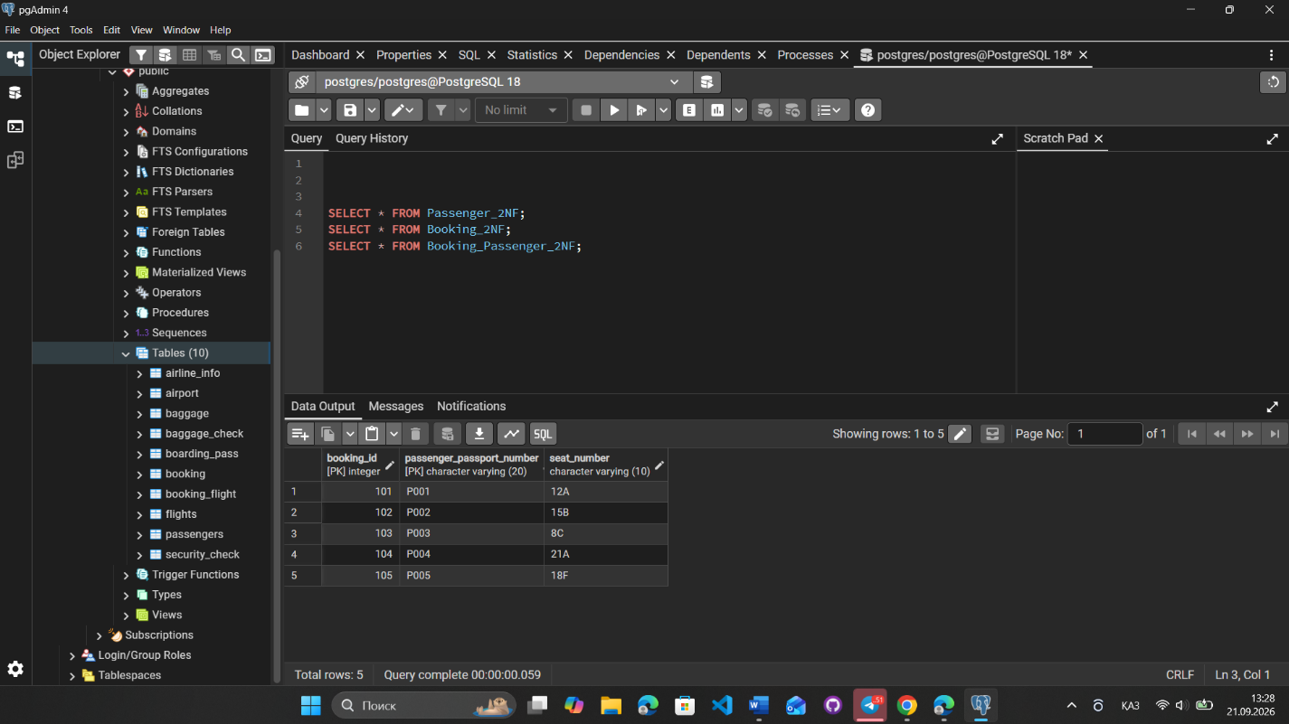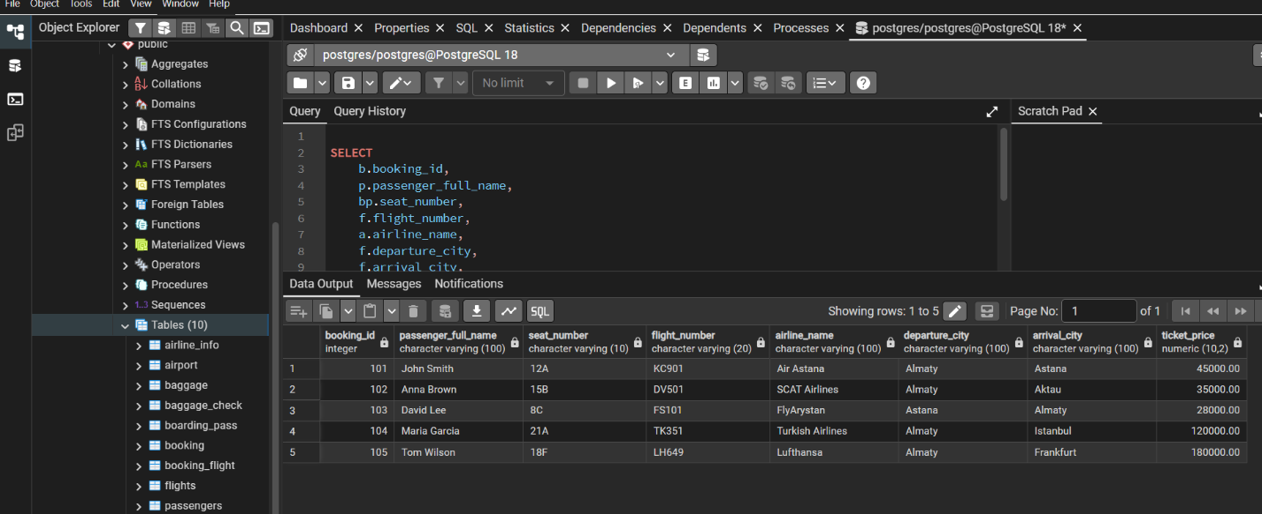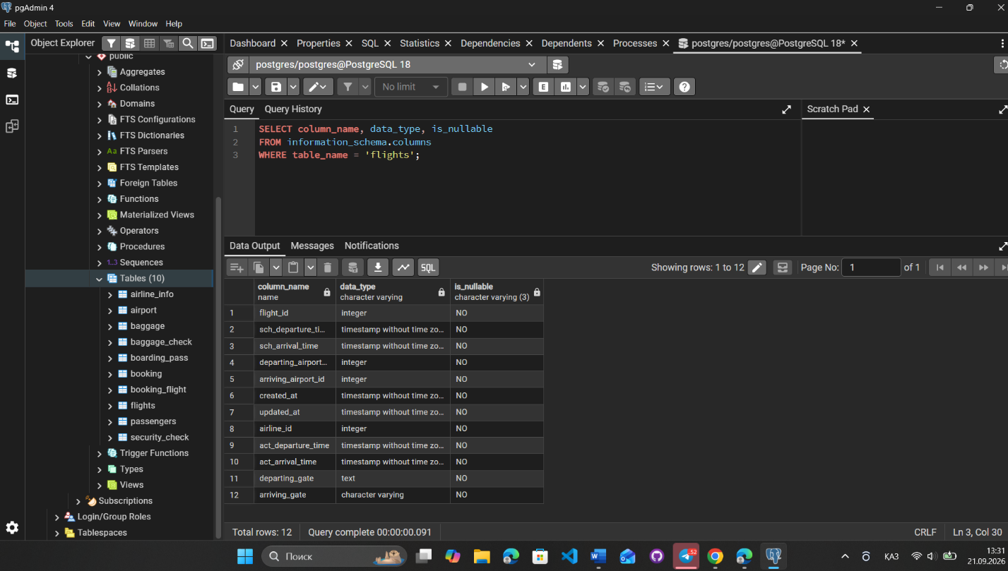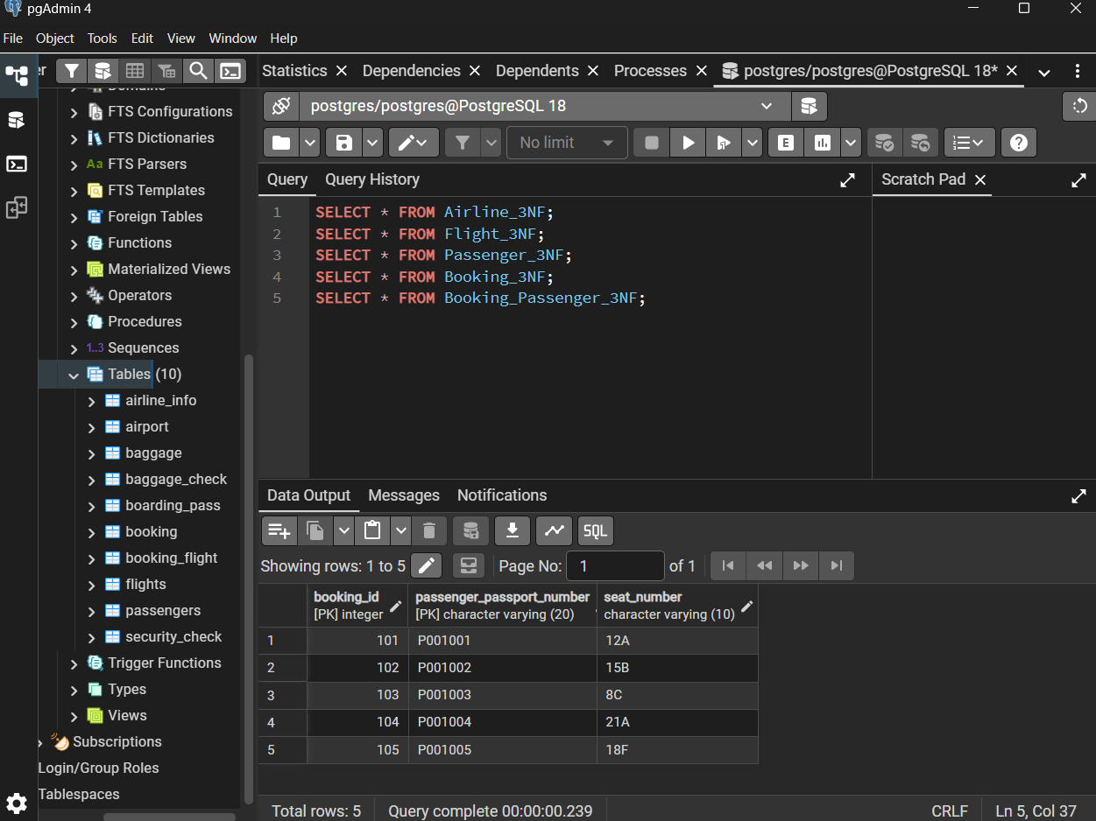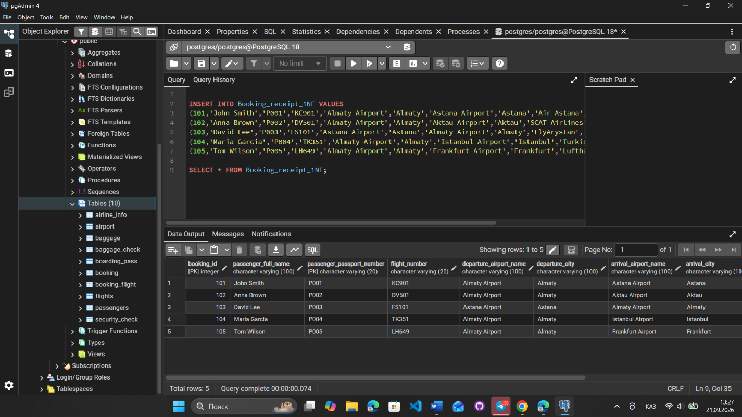
During this laboratory work, the Booking_receipt table was normalized to 1NF, 2NF, and 3NF. Repeating data and dependencies between attributes were removed. The database tables were created with primary and foreign keys, sample records were added, and the relationships between the tables were checked.
As a result, the database structure was organized according to the requirements of the Third Normal Form (3NF).
